2.7.1 - Student Satisfaction Survey (SSS)
2021-2022
Feedback is very important to decide major decisions of any college. Thus it is very important information. Appropriate feedback has effective advantages for the students, the professors, the principal and the whole institute. It is one of the apt means to uplift the performance. Moreover, it provides a proper style for improvement. This survey includes the design of questions recommended by NAAC. It has included teaching-learning, Mentoring and evaluation aspects. Moreover, the survey consists of infrastructure and welfare aspects of the institution. The learners were provided the feedback on the google form. In this way, Dharmendrasinhji Arts College, Rajkot SSS was conducted online by providing the google form with questions.
The following points are observed through SSS:
Sr. No. | Parameters | Responses
1 | Teaching -Learning Process | More than 50% of the students have  responded positively.
2 | The Teaching and Mentoring Process in your institution | Almost all learners responded that the Teaching and Mentoring Process is really beneficial.
3 | Internal- Evaluation | Almost all learners, more than 60%, believed that the evaluation was impartial.
4 | Co-curricular Activities | Our college regularly takes active interest in promoting extracurricular activities. All the students replied in a positive way.
5 | Basic and Physical Facilities | The students think that physical  facilities provided by the college are really helpful to them.
6 | Preparation of Academician | Almost every undergraduate responded excellently and very good in Preparation of the teacher for class.

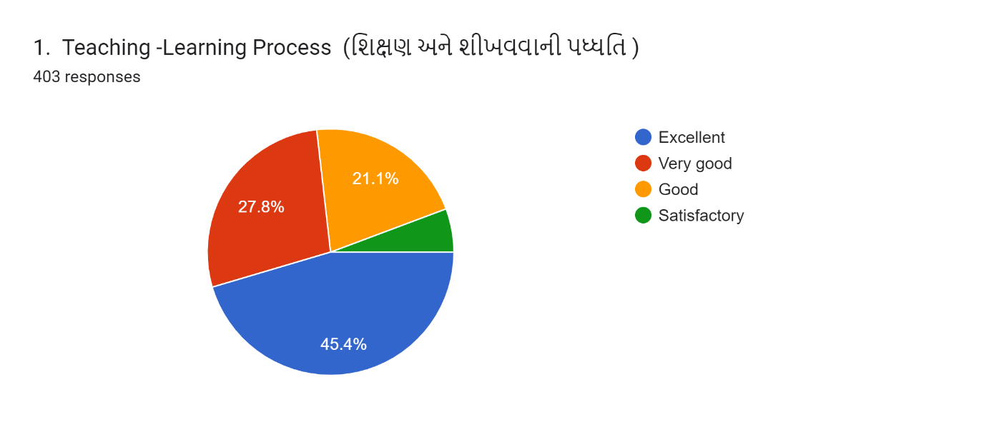
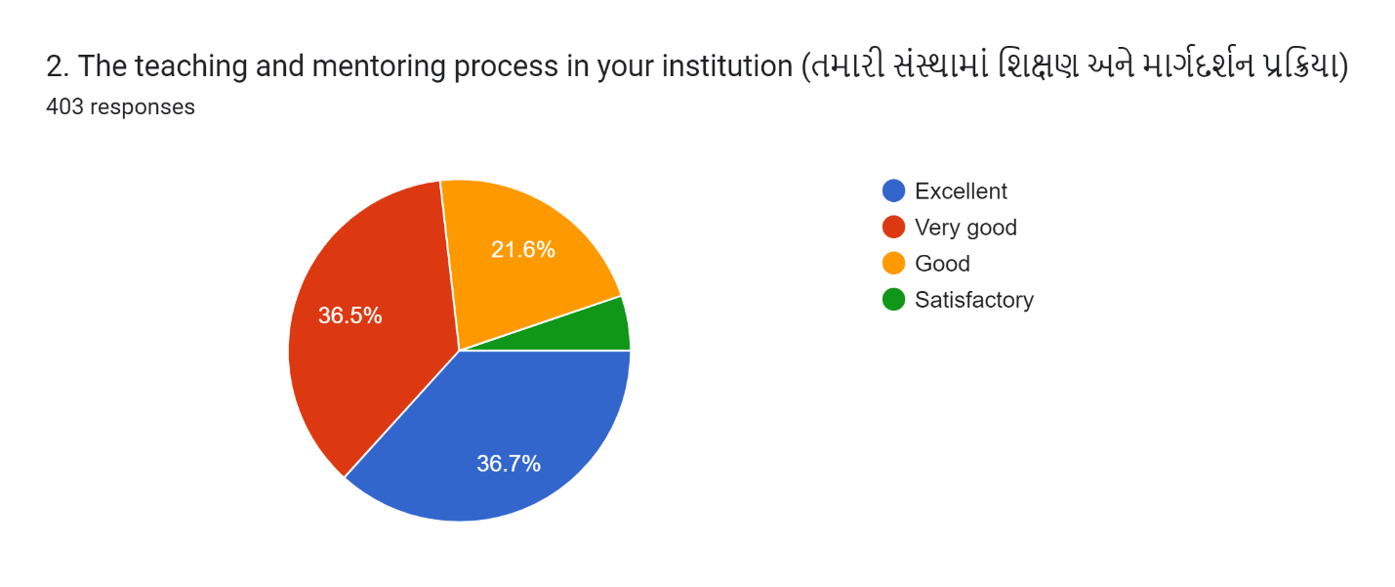
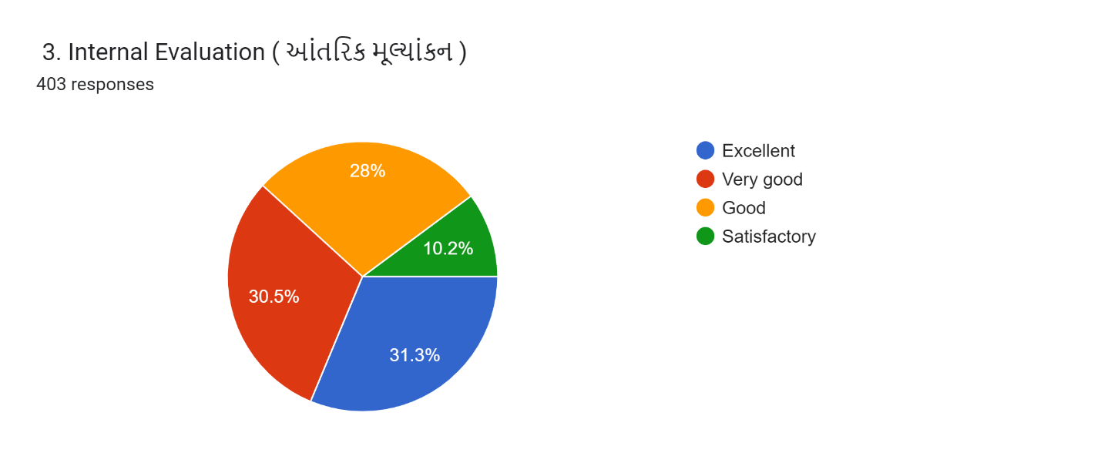
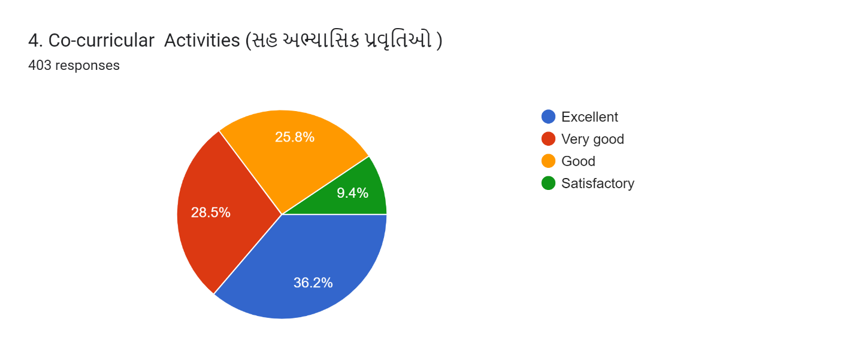

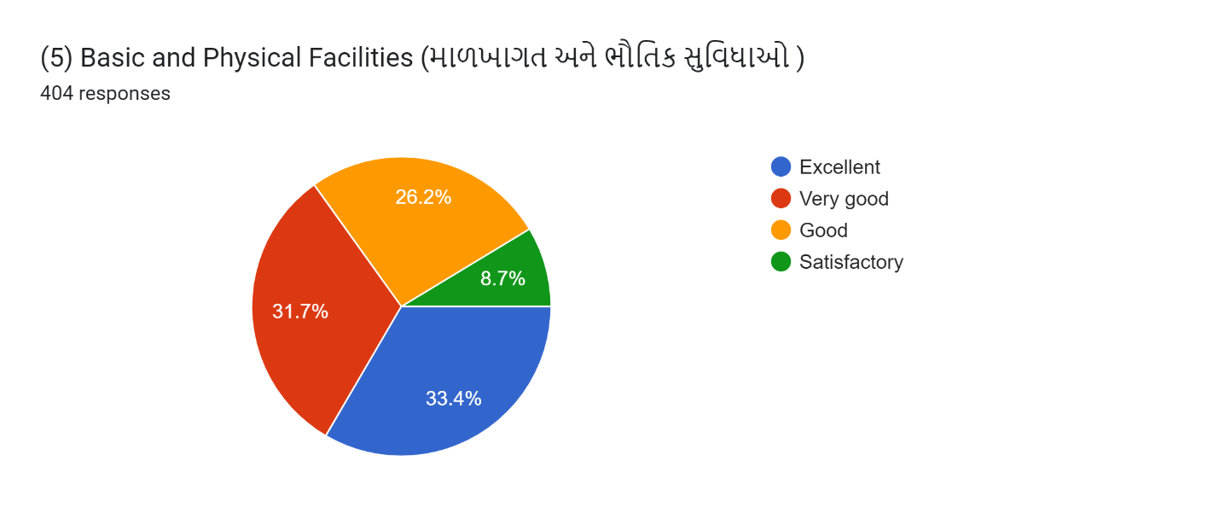
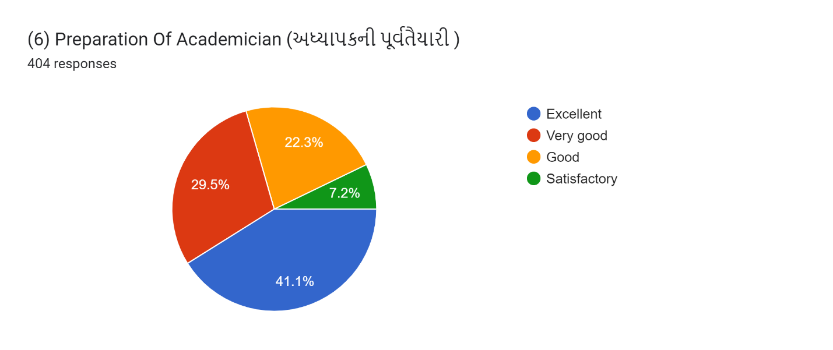
Average of SSS
Excellent= 37.35
Very Good =30.75
Good = 24.16
Satisfactory = 7.7

